**DELUXE PEDESTAL ENERGY SAVER FANS:**

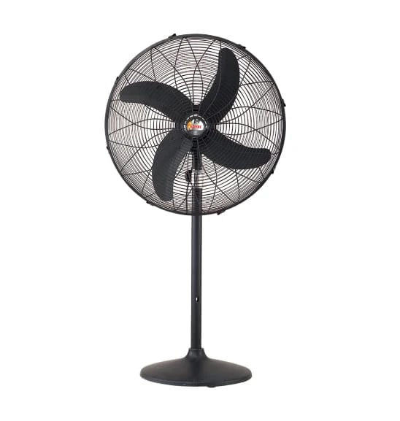

**Price: 16,595.00**

The Deluxe Pedestal Energy Saver Fan is a premium and eco-friendly cooling solution, designed to provide powerful airflow while minimizing energy consumption. With its robust and adjustable pedestal design, this fan delivers focused airflow and can be customized to fit various spaces. Equipped with a high-efficiency motor and aerodynamically designed blades, the Deluxe Pedestal Energy Saver Fan ensures exceptional air circulation while using significantly less power. Its sleek and modern design adds a touch of sophistication, making it perfect for homes, offices, and commercial spaces seeking a reliable and energy-efficient cooling solution.

**Key features of deluxe pedestal energy saver fans include:**

* **Energy-Efficient**: Designed to use less power, helping to reduce electricity bills.
* **Adjustable Height**: Allows customization for optimal air circulation in different spaces.
* **Oscillation**: Provides widespread airflow by rotating from side to side.
* **Multiple Speed Settings**: Offers various speed options (low, medium, high) for different cooling needs.
* **Quiet Operation**: Built to operate quietly, ensuring minimal disturbance while cooling.
* **Sturdy Construction**: Durable design for long-lasting performance.
* **Tilt Function**: Adjustable tilt to direct airflow in desired directions for better coverage.